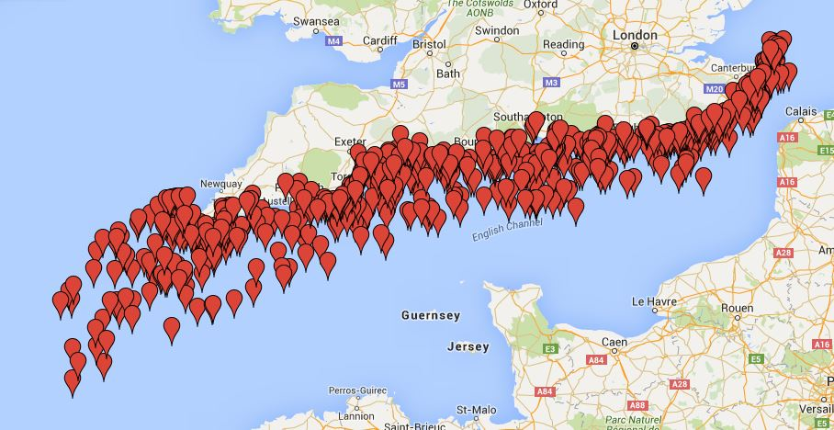
Forgotten Wrecks of the First World War
Each ‘pin’ on the map shows where a ship sank during the First World War (1914 – 1918). There are about 1,000 First World War wrecks off southern England!
What sort of craft do you think they were?
Ship Type |  | Ship Type |  | Ship Type | 
Hospital ship |  | Battleship |  | U-boat
Cargo ship |  | Trawler |  | Submarine
Fishing boat |  | Mine-layer |  | Sailing ship
Airship |  | Mine-seeker |  | Yacht
Passenger liner |  | Plane |  | Mystery ship (in disguise)
Animal transporter |  | Troop carrier |  | All of these!

Why do you think they sank?
Sank because of |  | Sank because of | 
Torpedoed by U-boat |  | Explosion on board
Gunfire from U-boat |  | Hit a mine
Bomb placed on ship by U-boat |  | Hit another boat
Hit land or rocks |  | Nobody knows!
Bad weather |  | All of these!

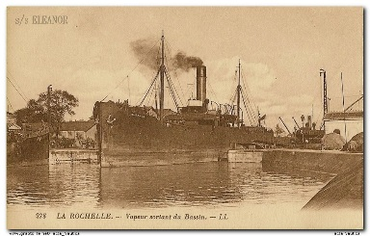
Most of the First World War south coast wrecks were ships that transported people, animals and things: merchant ships.
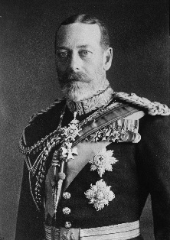
After the war, King George V created the title ‘Merchant Navy’ to honour the vital role that such ships played during the war. A new medal was introduced called the Mercantile Marine Medal.
A First World War merchant ship
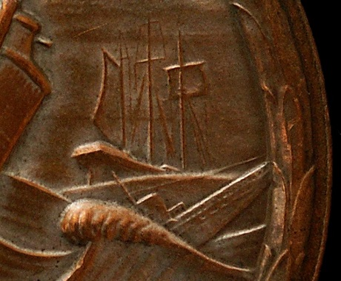
It had the head of King George V on the front and on the back: 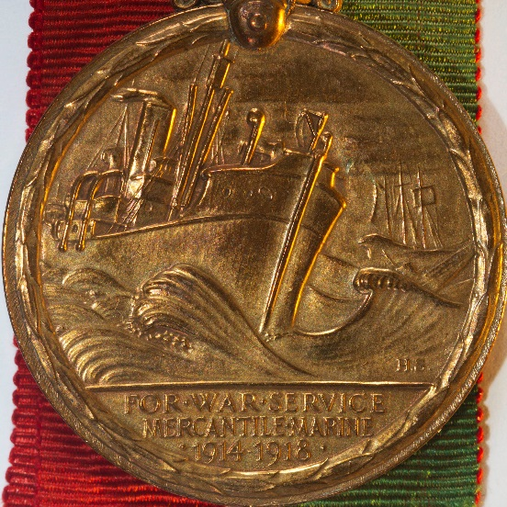
King George V
Steam ship
German U-boat coming out of the waves
Sailing ship
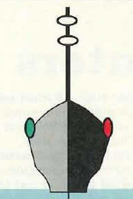
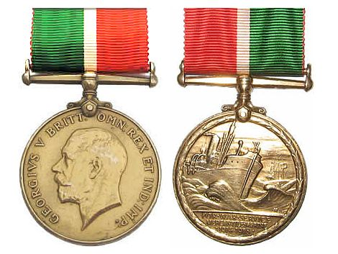
Mercantile Marine Medal
The colours of the medal’s ribbon represents the navigation lights on a ship:
Green (starboard/right)
Red (port/left)
White (steaming light on top of mast).

Design your own medal and ribbon!

Front | Back
